MZT
Laboratorium 1
Przemysław Kleszcz
Nr albumu: 124624

Platforma testowa
Procesor | Intel Core i5-7440HQ, 2.8GHz, 6MB Cache
RAM | DDR4 - 16 GB
System operacyjny | Microsoft Windows 10 Pro
Środowisko programistyczne | Visual Studio Professional 2017 v15.5.7
Środowisko uruchomieniowe | .NET Framework 4.6.01055

Zadanie 1
void matvec_opt_1(double* a, double* x, double* y, int n)
/*=========================================================================
Usuniecie skokow w danych
===========================================================================*/
{
int i, j = 0, k = 0;
memset(y, 0, n * sizeof(double));
double register r;
for (j = 0; j<n; j++) {
r = x[j];
for (i = 0; i<n; i++) {
y[i] += a[k++] * r;
}
}

}

void matvec_opt_2(double* a, double* x, double* y, int n)
/*============================================================================
Rozwijanie petli
=============================================================================*/
{
int rest = n % 8;
int i = 0, j = 0, ij = 0;
double register r = 0;

memset(y, 0, n * sizeof(double));

for (j = 0; j < n; ++j) {
r = x[j];
for (i = 0; i < n - rest; i += 8) {
y[i] += a[ij] * r;
y[i + 1] += a[ij + 1] * r;
y[i + 2] += a[ij + 2] * r;
y[i + 3] += a[ij + 3] * r;
y[i + 4] += a[ij + 4] * r;
y[i + 5] += a[ij + 5] * r;
y[i + 6] += a[ij + 6] * r;
y[i + 7] += a[ij + 7] * r;
ij += 8;
}

for (; i < n; ++i) {
y[i] += a[ij++] * r;
}
}

}

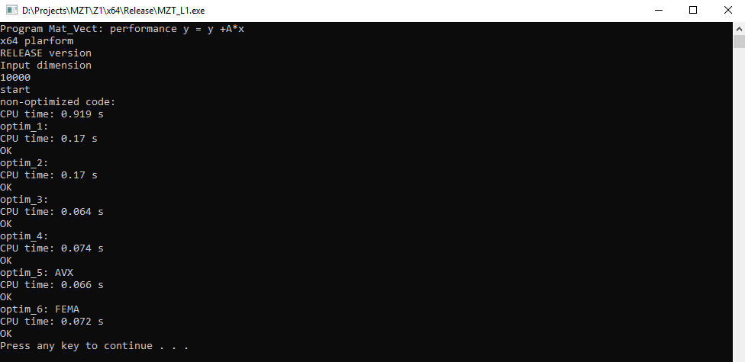

Zadanie 2
void matvec_XMM(double* a, double* x, double* y, int n, int lb)
{
int i, j;
__m128d rx0, ra0, ry0;
double *ptr_x, *ptr_a;
__declspec(align(16)) double tmp[2];
memset((void *)y, 0, n * sizeof(double));
ptr_a = a;
for (i = 0; i < n; i++)
{
ry0 = _mm_setzero_pd();
ptr_x = x;
for (j = 0; j < n; j += 2, ptr_a += 2, ptr_x += 2)
{
rx0 = _mm_load_pd(ptr_x);
ra0 = _mm_load_pd(ptr_a);
ra0 = _mm_mul_pd(ra0, rx0);
ry0 = _mm_add_pd(ry0, ra0);
}
_mm_store_pd(tmp, ry0);
y[i] = tmp[0] + tmp[1];
}
}
void matvec_YMM(double* a, double* x, double* y, int n, int lb)
{
int i, j;
__m256d rx0, ra0, ra1, ra2, ra3, ry0, ry1, ry2, ry3;
double *ptr_x, *ptr_a;
__declspec(align(16)) double tmp0[4], tmp1[4], tmp2[4], tmp3[4];
memset((void *)y, 0, n * sizeof(double));
ptr_a = a;
for (i = 0; i < n; i += 4)
{
ry0 = ry1 = ry2 = ry3 = _mm256_setzero_pd();
ptr_x = x;
for (j = 0; j < n; j += 16)
{
_mm_prefetch((const char *)(ptr_x + 16), _MM_HINT_T0);
_mm_prefetch((const char *)(ptr_x + 24), _MM_HINT_T0);
_mm_prefetch((const char *)(ptr_a + 16), _MM_HINT_NTA);
_mm_prefetch((const char *)(ptr_a + 24), _MM_HINT_NTA);
//poprawic
//--------------------------0
rx0 = _mm256_load_pd(ptr_x);
ra0 = _mm256_load_pd(ptr_a);
ra1 = _mm256_load_pd(ptr_a + n);
ra2 = _mm256_load_pd(ptr_a + 2 * n);
ra3 = _mm256_load_pd(ptr_a + 3 * n);
ra0 = _mm256_mul_pd(ra0, rx0);
ra1 = _mm256_mul_pd(ra1, rx0);
ra2 = _mm256_mul_pd(ra2, rx0);
ra3 = _mm256_mul_pd(ra3, rx0);
ry0 = _mm256_add_pd(ry0, ra0);
ry1 = _mm256_add_pd(ry1, ra1);
ry2 = _mm256_add_pd(ry2, ra2);
ry3 = _mm256_add_pd(ry3, ra3);
//-------256----------------1
rx0 = _mm256_load_pd(ptr_x + 4);
ra0 = _mm256_load_pd(ptr_a + 4);
ra1 = _mm256_load_pd(ptr_a + n + 4);
ra2 = _mm256_load_pd(ptr_a + 2 * n + 4);
ra3 = _mm256_load_pd(ptr_a + 3 * n + 4);
ra0 = _mm256_mul_pd(ra0, rx0);
ra1 = _mm256_mul_pd(ra1, rx0);
ra2 = _mm256_mul_pd(ra2, rx0);
ra3 = _mm256_mul_pd(ra3, rx0);
ry0 = _mm256_add_pd(ry0, ra0);
ry1 = _mm256_add_pd(ry1, ra1);
ry2 = _mm256_add_pd(ry2, ra2);
ry3 = _mm256_add_pd(ry3, ra3);
//-------256----------------2
rx0 = _mm256_load_pd(ptr_x + 8);
ra0 = _mm256_load_pd(ptr_a + 8);
ra1 = _mm256_load_pd(ptr_a + n + 8);
ra2 = _mm256_load_pd(ptr_a + 2 * n + 8);
ra3 = _mm256_load_pd(ptr_a + 3 * n + 8);
ra0 = _mm256_mul_pd(ra0, rx0);
ra1 = _mm256_mul_pd(ra1, rx0);
ra2 = _mm256_mul_pd(ra2, rx0);
ra3 = _mm256_mul_pd(ra3, rx0);
ry0 = _mm256_add_pd(ry0, ra0);
ry1 = _mm256_add_pd(ry1, ra1);
ry2 = _mm256_add_pd(ry2, ra2);
ry3 = _mm256_add_pd(ry3, ra3);
//-------256----------------3
rx0 = _mm256_load_pd(ptr_x + 12);
ra0 = _mm256_load_pd(ptr_a + 12);
ra1 = _mm256_load_pd(ptr_a + n + 12);
ra2 = _mm256_load_pd(ptr_a + 2 * n + 12);
ra3 = _mm256_load_pd(ptr_a + 3 * n + 12);
ra0 = _mm256_mul_pd(ra0, rx0);
ra1 = _mm256_mul_pd(ra1, rx0);
ra2 = _mm256_mul_pd(ra2, rx0);
ra3 = _mm256_mul_pd(ra3, rx0);
ry0 = _mm256_add_pd(ry0, ra0);
ry1 = _mm256_add_pd(ry1, ra1);
ry2 = _mm256_add_pd(ry2, ra2);
ry3 = _mm256_add_pd(ry3, ra3);
ptr_a += 16;
ptr_x += 16;
}
ptr_a += 3 * n;
_mm256_store_pd(tmp0, ry0);
_mm256_store_pd(tmp1, ry1);
_mm256_store_pd(tmp2, ry2);
_mm256_store_pd(tmp3, ry3);
y[i] = tmp0[0] + tmp0[1] + tmp0[2] + tmp0[3];
y[i + 1] = tmp1[0] + tmp1[1] + tmp1[2] + tmp1[3];
y[i + 2] = tmp2[0] + tmp2[1] + tmp2[2] + tmp2[3];
y[i + 3] = tmp3[0] + tmp3[1] + tmp3[2] + tmp3[3];
}
}

